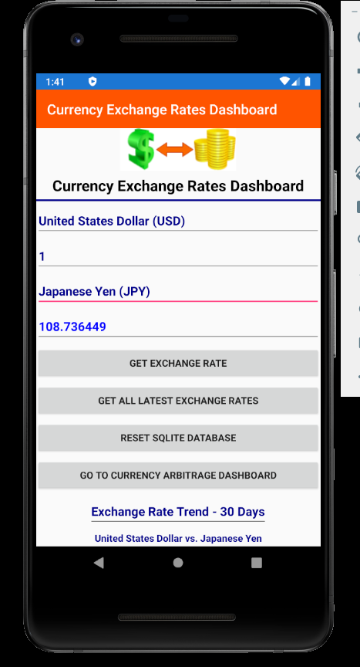Home page:

Here we are at the home page.

Here you can find out how much your money you’ll have at that country where your plane is about to land on. Beware not to be scammed. These calculations come from the table CurrencyExchangeRates.

Also, available is the 30 day trend for the said currencies. This way you know when to strike while the iron is hot. Find out when to buy that vacation currency. These data come from table CurrencyExchangeRatesArchive

Now let’s proceed to the two buttons that will bring you somewhere else: “Get All Latest Exchange Rates” and “Go To Currency Arbitrage Dashboard”

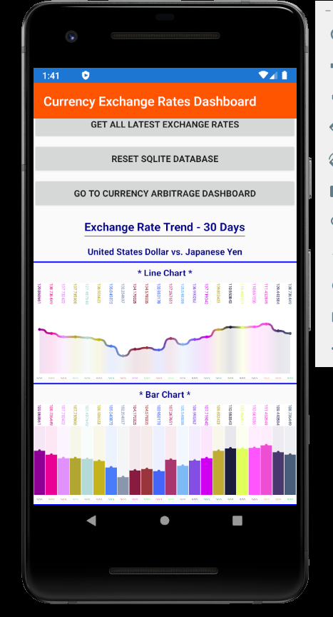<mentioned in previous screenshot. Scroll to this as needed >

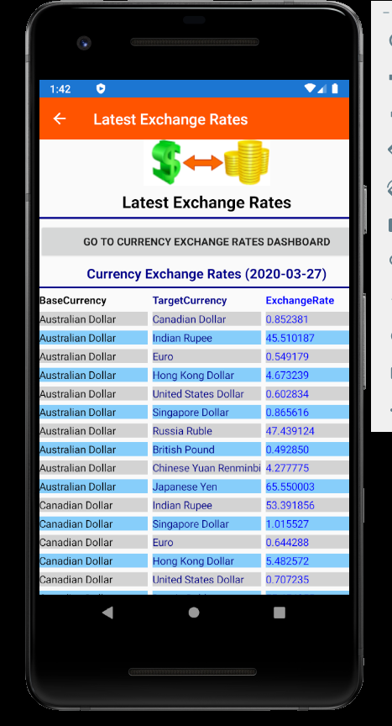“Get All LatestExchange Rates” button will get you here.

If you go country hopping, this is the place for you. In one view, you can find out how strong your currency is.

Data comes from table CurrencyExchangeRates

“Go To Currency Arbitrage Dashboard”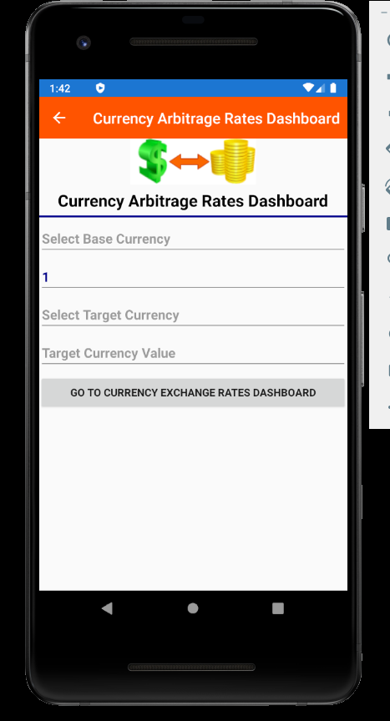 button will lead you here.

This is a guide on how to make money. Choose a base and target currency and how many hops you want and we’ll let you know if you have a gain. No need to lose. Check before you exchange that.

This has been precalculated daily and stored in the table CurrencyArbitrageLog